**WINDOWS 11:**

**Operating System**

**ITP51 – OPERATING SYSTEMS**

TABLE OF CONTENTS

**Chapter 01 Introduction and History 03**



**Chapter 02 Process Management 08**



**Chapter 03 CPU Scheduling 12**



**Chapter 04 Memory Management 16**



**Chapter 05 Storage Management 19**



**Chapter 06 I/O Systems 21**



**Chapter 07 File Systems 25**



**References 29**

CHAPTER 1

**INTRODUCTION AND HISTORY**

The known Windows 11 (2021) was once a MS-DOS-Microsoft Disk Operating System (1981). The Windows operating system has undergone a remarkable evolution since its initial release in 1985. Windows OS, developed by Microsoft Corporation, is a widely utilized and influential operating system that has played an important role in shaping personal computing since its establishment. Windows OS is recognized for its user-friendly interface, compatibility with a diverse range of software and hardware, and continuous evolution of features. The series comprises various editions, each building upon its very first version, Windows 10 and Windows 11 are standing out as noteworthy recent releases. These various editions of Windows brought about significant advancements that enhanced the functionality of the operating system. Notably, the iterations featured the inclusion of native programs such as Windows File Manager, Program Manager, and Print Manager. These additions streamlined user interactions and improved overall system management. Windows OS is essential to millions of devices globally, spanning from PCs, desktop computers to laptops, tablets, and more, offering users a versatile platform for work, study, entertainment, and communication. These iterative improvements of each version release marked Microsoft's commitment to refining the Windows operating system, enhancing user experience, and expanding its capabilities over time.

The first edition of Windows in 1985 marked an important and lasting change experience in computing history. It was initially conceived as a graphical user interface (GUI) extension of Microsoft's existing disk operating system, MS-DOS. Then Windows departed from its traditional text-based commands ever since it was inspired by the concepts licensed from Apple Inc.'s Macintosh System Software. This pioneering version of Windows empowered MS-DOS users to explore a virtual desktop visually. Through a click of a mouse button, users could open graphical "windows" that displayed the contents of electronic folders and files, eliminating the need for manual input of commands and directory paths at a text prompt. This groundbreaking shift towards a more user-friendly interface laid the foundation for the future evolution of the Windows operating system. On the other side, command prompts are still available in Windows OS by typing “cmd” in the file explorer.

This marks the origination of Windows with the release of Windows 1.0. Although initially announced in November 1983 under the name "Windows," it wasn't until November 1985 that the operating system made its official debut. Windows 1.0 represented Microsoft's first step in attempting a graphical user interface within a 16-bit environment. Windows 3 is the first Windows that required a hard drive launched in 1990. The release of Windows 95 marked a significant milestone as it fully integrated Windows and DOS, providing seamless compatibility. This version also introduced built-in Internet support, featuring the World Wide Web browser Internet Explorer, it also brought the first ever Start button and Start menu.

In 2001, with the launch of Windows XP, Microsoft consolidated its diverse Windows packages into a unified system, offering tailored editions for users. Windows XP departed from the Windows 95 kernel, adopting a more robust code base. It presented users with a practical interface, improved application management, and enhanced memory handling. Arguably Windows XP is considered one of the best Windows versions. The success of Windows XP paved the way for Windows Vista in late 2006. However, Vista faced challenges during its rollout, encountering significant resistance in the marketplace due to perceptions of being large, slow, and resource-intensive. Responding to these challenges, Microsoft released Windows 7 in 2009, featuring an interface similar to Vista but distinguished by notable speed improvements and more modest system requirements, which were well-received by users. In 2012, Windows 8 introduced a start screen with applications presented as tiles on a grid. It also offered the ability to synchronize settings, allowing users to log on to another Windows 8 machine and use their preferred configurations. The release of Windows 10 in 2015 marked the introduction of Cortana, a digital personal assistant similar to Apple’s Siri, and the debut of the Microsoft Edge web browser, replacing Internet Explorer.

Succeeding Windows 10, Windows 11 is the most recent iteration of Microsoft's long-standing and influential operating system (OS) series. Unveiled on June 24, 2021, by Microsoft CEO Satya Nadella, Windows 11 represents a significant leap forward in terms of design, functionality, and user experience. The OS is designed to provide a more streamlined and intuitive computing experience, with a focus on productivity, creativity, and collaboration.

The development of Windows 11 builds upon the foundation laid by its predecessor, Windows 10. With a renewed focus on performance and aesthetics, Microsoft set out to design an operating system that could adapt to the changing needs of its customers. The formal declaration was made at a virtual event when Microsoft unveiled the new functionalities and aesthetic components that would characterize Windows 11. The enhanced user interface of Windows 11 is among the most obvious modifications. Specifically, the Start Menu received a major makeover, shifting from the left side of the screen to the center. A more simplified, contemporary design for the Start Menu that incorporates Live Tiles, making for a more aesthetically pleasing and adaptable experience.

Snap Layouts and Snap Groups are two of the new window management features included in Windows 11. With Snap Layouts, users may efficiently multitask by organizing and snapping numerous application windows in a grid-like pattern. With Snap Groups, users can quickly navigate between groups of apps that they frequently use together, which improves workflow and productivity. Windows 11 has undergone a comprehensive redesign of the Microsoft Store, introducing a more organized and user-friendly interface. The store has been expanded to offer a broader group of applications, incorporating support for Android apps through the Amazon Appstore. This expansion is geared towards providing users with a more diverse and extensive selection of software. Furthermore, Windows 11 seamlessly integrates Microsoft Teams, the platform for collaboration and communication. This integration goes beyond incorporating Teams directly into the taskbar, ensuring easy accessibility for users. This direct integration facilitates efficient communication, enabling users to connect with colleagues, friends, or family for video calls, chats, and collaborative endeavors. Windows 11 brings significant enhancements for gamers, enhancing the overall gaming experience. For instance, the DirectStorage for faster loading times, Auto HDR for a more vibrant gaming experience, and support for technologies like Direct3D 12 Ultimate. These features aim to provide gamers with a more enjoyable and technologically advanced gaming platform.

Windows 11 is available in several editions tailored to different user needs. First is the Windows 11 Home, designed for home users. It includes essential features like the new Start menu, Taskbar, virtual desktops, and support for universal Windows apps. It is ideal for users seeking basic functionality without advanced management or security features. Next is the Windows 11 Pro, which is geared towards small businesses and advanced users. It encompasses all features of Windows 11 Home and introduces additional capabilities, including Windows Update for Business, Hyper-V virtualization, BitLocker encryption, and Remote Desktop. It is suited for businesses that require advanced management and security features. Lastly, the Windows 11 Enterprise that tailored for large organizations and enterprises. It incorporates all features of Windows 11 Pro with further additions like Windows Defender Application Guard, Windows Sandbox, and Credential Guard. Ideal for organizations with heightened security and advanced management requirements. These editions provide a tiered approach, allowing users to choose the version that aligns with their specific needs, whether for home use, business operations, or enterprise-level security and management.

Overall, Windows 11 represents a new stage in the development of Microsoft's operating systems. With its enhanced productivity capabilities, current computing needs, and streamlined design, Windows 11 strives to provide a creative and intuitive experience across a broad spectrum of devices. With Windows 11, Microsoft has demonstrated its dedication to expanding the capabilities of an operating system while keeping up with technological

CHAPTER 2

**PROCESS MANAGEMENT**

Process management in an operating system encompasses a set of activities involved in creating, scheduling, and terminating processes. It can be conceptualized as an instance of a program that is currently in execution on a computer system. In any modern operating system, it is a vital aspect of managing the processes, as it allows the concurrent execution of multiple programs and efficient sharing of system resources.

The process management OS (Operating System) subsystem is in charge of allocating system resources, including CPU time, memory, and input/output devices, to running or active processes. Additionally, it is also responsible for scheduling the execution of processes in a way that optimizes system throughput and minimizes response times.

An executing program is called a process. It is a unit of work within the system and is also known as a loaded instance. In the context of a process, one or more threads are active. A thread represents the fundamental unit to which the operating system allocates processor time. A process is essentially a container for its threads in the Windows operating system, with the process itself not directly executing code. Alternatively, it serves as a management unit for the threads it contains. An executable unit of code is a thread, that can be scheduled by the kernel dispatcher. When a process is initiated, it begins with a single thread. This initial thread may either start running immediately or be initiated in a suspended state, waiting for an explicit request to start. The presence of active threads within the process determines its lifespan. As long as relevant threads are executing within the process, it is considered to be in a running state.

One of the characteristics of a process is a Process ID. A unique identifier known as a Process ID (PID) is assigned to each process in Windows 11 Operating System. The Process ID is a numerical value that distinguishes one running process from another in the operating system. It serves as a means of identifying and managing processes within the system.

Process management in Windows 11 involves various components and functionalities that oversee the execution of tasks, optimize resource utilization, and ensure the overall efficiency of the operating system. There are some key aspects of process management in Windows 11, such as Task Manager, Multitasking and Virtual Desktops, Resource Allocation, Background Processes and Services, Power Management, Error Handling and Recovery, and Security and Isolation.

* **Task Manager.** The graphical user interface for managing processes is known as the Task Manager. It is a central tool in Windows for monitoring and managing processes. Task Manager allows users to view and manage the information about each process, including details of the resource usage (CPU, memory, disk, and network), status, and priority. This utility serves as a central hub for monitoring and controlling processes, allowing users to terminate or restart processes, adjust their priority as needed, and set their affinity to specific processor cores. Task Manager provides users with a user-friendly interface to effectively oversee and manage the various processes running on the system.
* **Multitasking and Virtual Desktops.** The ability to execute more than one task at the same time is Multitasking. The Windows 11 operating system used preemptive multitasking, a mechanism that allocates a specific time slice, or quantum, to each thread it executes. Multitasking features like Snap Layouts and Snap Groups are supported in Windows 11 OS. Users can organize and manage multiple open applications using Snap Layouts, and create Snap Groups for efficient switching between sets of applications. On the other hand, Virtual Desktops provide additional workspace, helping users manage processes in a more organized manner.
* **Resource Allocation.** In Windows 11 OS there is a dynamic allocation of system resources to running processes. The operating system maximizes resource usage such as CPU, memory, and disk, ensuring efficient resource allocation. To achieve this, Windows 11 employs various algorithms to prioritize active processes and allocate resources in response to changing demands.
* **Background Processes and Services.** In the Windows 11 OS, numerous background processes and services are actively running. These background processes and services handle essential system functions, ensuring the smooth operation of the operating system. For instance, the system maintenance tasks, security updates, and background applications.
* **Power Management.** Windows 11 incorporates power management features. The operating system manages power settings to optimize energy consumption based on the device's state and user preferences. This involves implementing features like Sleep mode and power plans.
* **Error Handling and Recovery.** The operating system monitors processes for errors and provides error-handling mechanisms. In case of application or system errors, Windows 11 may attempt to recover or restart processes to maintain system stability.
* **Security and Isolation.** Security features in Windows 11 OS, such as Windows Defender Application Guard, help isolate potentially malicious processes, enhancing the overall security of the system.

Overall, process management OS is an important aspect of any modern operating system. It is responsible for allocating system resources and ensuring that processes run efficiently. Process management OS plays a vital role in ensuring the smooth operation of an operating system. Furthermore, it is important to understand and manage these key aspects of process management in Windows 11 to maintain its system performance, stability, and security. The operating system's user interface and system settings provide users with tools to monitor and control various processes for an optimal computing experience.

CHAPTER 3

**CPU SCHEDULING**

Scheduling is one of the most important areas in which programs will work on the CPU. The Operating System (OS) of the computer is responsible for handling this task, as there are a lot of different ways in which we can select an option to configure programs. The allocation of CPU time to various tasks within an operating system is the job of Scheduling. Scheduling of processes is done to finish the work on time. Scheduling plays a vital role in many different computer environments. A scheduling algorithm determines the order in which these processes are granted access to the CPU. The purpose is to achieve efficient and fair utilization of the CPU, optimizing system performance and responsiveness.

CPU Scheduling is an essential part of the operating system, as it is a process of deciding and allowing which process will use the computer's central processing unit (CPU) while another process is delayed or on standby because of the unavailability of any resources such as I/O resources, etc., thus making full use of the CPU. Guaranteeing that whenever the CPU remains idle, the OS has at least chosen one of the processes available in the ready-to-use line is the main function of CPU Scheduling and its objective is to enhance system efficiency, speed, and fairness.

There are two types of scheduling methods which are Preemptive Scheduling and Non-Preemptive Scheduling. Windows 11 OS implements a priority-driven, preemptive scheduling system, allowing a currently running process to be interrupted and moved to the waiting queue if a higher-priority process becomes ready to execute. Preemptive scheduling is utilized when a process shifts from the running state to the ready state or from the waiting state to the ready state.

Windows operating systems, including the latest Windows 11, typically apply a combination of scheduling algorithms to efficiently manage CPU resources. The latest major release of Microsoft's Windows NT operating system is Windows 11 and in Windows NT versions Microsoft they used a Round-Robin with and Multilevel Feedback Queue for priority base scheduling ever since its release. The Multiple Queue Scheduling algorithm is also used in Windows 11.

* In CPU scheduling, one of the most widely adopted methods as a core is the **round-robin** (GeeksforGeeks, 2023). This preemptive scheduling algorithm allocates a fixed time slice or quantum to each process and rotates through the processes in a circular queue. Round Robin CPU Algorithm is primarily designed for Time Sharing technique and ensures fair CPU time distribution among processes and helps prevent any single process from monopolizing/dominating the CPU. This approach is simple, easy to use, and starvation-free as all processes are provided with a balanced CPU allocation.

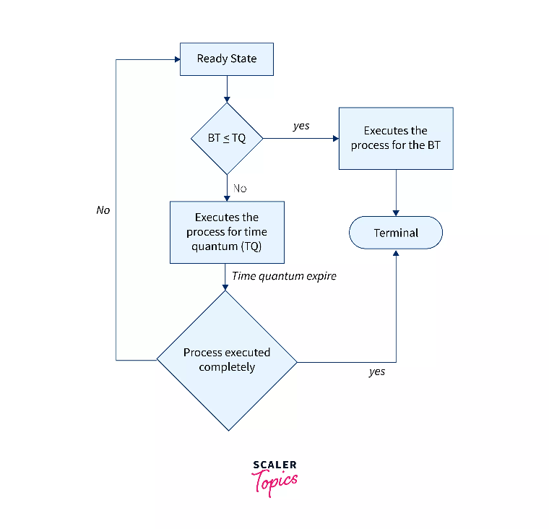

**Figure 1. Round Robin Scheduling**

* **Multilevel queue scheduling** is a method that divides processes into several separate queues based on the assigned priority or other criteria of each queue. Each queue may have its own scheduling algorithm that they can use, allowing for differentiated treatment of processes depending on their characteristics or priority levels. This approach is useful in situations where different types of processes have different priorities.

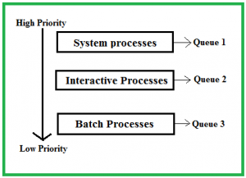

**Figure 2. Multilevel Queue Scheduling**

The description of the processes in the above figure is as follows:

* System Processes. The CPU itself has its processes to run, these are generally termed System Processes and are essential for the functioning of the operating system. (GeeksforGeeks, 2023).
* Interactive Processes. A type of process in which there should be the same type of interaction is an Interactive Process (GeeksforGeeks, 2023).
* Batch Processes. The technique employed in the Operating system that collects the programs and data together in the form of a batch before the processing starts is Batch processing (GeeksforGeeks, 2023).
* **Multilevel Feedback Queue Scheduling (MLFQ)** is widely used in modern operating systems due to its adaptability to various types of processes and its capability to provide a balance between throughput and responsiveness. It represents adynamic CPU Scheduling that is like Multilevel Queue Scheduling however in this approach, it allows processes to move between different queues. Thus, much more efficient compared to multilevel queue scheduling. In contrast to a multilevel queue-scheduling algorithm, where processes are permanently assigned to a queue on entry to the system, and processes are not allowed to move between queues, MLFQ adopts a more flexible approach. Multilevel Feedback Queue Scheduling segregates processes into distinct queues depending on their behavior and execution history. It is mainly designed to adapt to the varying needs of different types of processes and achieve a balance between responsiveness and throughput.

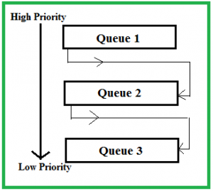

**Figure 3. Multilevel Feedback Queue Scheduling**

Windows 11 CPU scheduling is advanced and efficient, ensuring that processes are distributed evenly across the cores and ensuring optimal system performance. Preemptive scheduling helps to prioritize important processes and prevents resource starvation by suspending low-priority processes when required. Round-robin scheduling ensures that each process gets an equal amount of time in the CPU and is useful for time-sharing systems. Multilevel queue scheduling divides the processes into different categories and assigns them to different queues, enabling the system to handle varying priorities efficiently. Multilevel Feedback Queue Scheduling is similar to multilevel queue scheduling but allows processes to move between queues dynamically based on their behavior. Hence, different scheduling algorithms and strategies are employed based on the specific goals and characteristics of the operating system as it also ensures that the CPU is utilized effectively and that processes are executed in a manner that meets user expectations.

CHAPTER 4

**MEMORY MANAGEMENT**

Memory Management determines what is in memory and it is utilized by every Windows 11 machine in managing the system memory. According to Sheldon (2022), Memory management is the process of controlling and coordinating a computer's main memory. It ensures that blocks of memory space are properly managed and allocated so the operating system (OS), applications, and other running processes have the memory they need to carry out their operations.

Memory management in Windows 11 involves the efficient utilization and control of a computer's memory resources to ensure smooth operation and optimal performance. Here are key aspects of memory management in the Windows 11 operating system:

* **Virtual Memory:**
  + OS turns to virtual memory when the computer runs out of physical memory space. Windows 11, like many modern operating systems, uses virtual memory to provide a larger address space than the physical RAM (Random Access Memory) available. Virtual memory allows for the creation of a page file on the hard disk, serving as an extension of RAM.
* **Page File (swap space or swap file):**
  + The page file, also known as the swap file, is a reserved space on the hard disk that Windows uses as virtual memory. It is a system file that creates temporary storage space. It acts as a supplement to physical RAM, allowing the operating system to swap data between RAM and the page file as needed.
* **Page Faults:**
  + Windows 11 employs a page fault mechanism where data not currently in RAM is retrieved from the page file into memory when needed. Page faults occur when a program accesses data that is not currently in RAM.
* **Dynamic Memory Allocation:**
  + The allocation process of Windows 11 is automatic as it allocates and deallocates memory dynamically as processes are created and terminated. The operating system manages memory allocation for both system processes and user applications.
* **Memory Compression:**
  + Windows 11 includes memory compression techniques to reduce the need for swapping data between RAM and the page file, improving performance.
* **Driver and Kernel Memory:**
  + Windows 11 reserves portions of memory for device drivers and the kernel to ensure essential system functions operate efficiently.

Memory management in Windows 11 is a complicated and dynamic process directed at providing a seamless user experience while efficiently utilizing the available hardware resources. The operating system employs various strategies to balance the demands of multiple processes and applications running concurrently.

Windows 11 supports both 32-bit and 64-bit memory addressing, allowing for the use of larger amounts of RAM in 64-bit systems. The following are features of Windows Memory Addressing:

* **32-bit Process Address Space:**
  + Microsoft Windows has its own virtual address space for each 32-bit process, enabling it to address up to 4 gigabytes of memory. Then this virtual address space is divided into sections such as code, data, and stack.
* **64-bit Process Address Space:**
  + In a 64-bit version of Windows, each process has a much larger virtual address space, specifically an 8-terabyte address space. The extended address space in 64-bit systems allows for more extensive memory addressing and is particularly beneficial for applications that require large amounts of memory.
* **Thread Access to Process Address Space:**
  + All threads within a process have access to the visible address space of that process. Threads share the same virtual memory space within a process, allowing for efficient communication and data sharing among threads.
* **Isolation Between Processes:**
  + Each process has its own virtual address space, providing isolation and security. Threads within a process can access the shared virtual address space, but threads from one process do not have direct access to the memory of another process. This isolation protects the integrity and stability of individual processes, preventing one process from accessing the memory space of another program. Therefore, Windows 11 implements memory protection mechanisms.

CHAPTER 5

**STORAGE MANAGEMENT**

The operating system offers users a consistent and logical view of information storage by abstracting physical details to present a uniform perspective. The basic unit of storage in a file system is a **file**, it is managed by the OS, with each storage medium, such as disk drives or tape drives, controlled by specific device drivers. These devices may possess diverse properties, including access speed, capacity, data transfer rate, and access method (sequential or random), abstracted by the OS to provide a standardized interface. Files are typically organized into **directories**, forming a hierarchical structure for efficient data management. Access control mechanisms are implemented to regulate user or process access to files and directories, ensuring data security. Operating system activities encompass creating and deleting files and directories, offering primitives for file and directory manipulation, mapping files onto *secondary storage*, and implementing backup procedures to store copies on stable, *non-volatile storage* media. Overall, the file-system management functions of an operating system play a pivotal role in providing an organized, secure, and user-friendly means of storing and retrieving data across diverse storage devices.

**File Explorer** serves as the primary tool for managing files and folders within the Windows 11 operating system, offering capabilities to navigate the system and create, delete, and organize files and folders. Windows 11 supports various storage devices, including traditional magnetic disks (HDDs) and solid-state drives (SSDs). Magnetic disks are commonly used for mass storage due to their cost-effectiveness and larger capacities compared to SSDs. In most installations of Windows 11, the default file system is **NTFS** (New Technology File System), which supports features such as file and folder permissions, encryption, and compression. The Storage Spaces feature in Windows 11 enables the combination of multiple drives into a unified logical storage pool, providing options for redundancy or increased storage capacity, accessible through Settings > System > Storage. For enhanced data protection, Windows 11 Pro and Enterprise editions include BitLocker, a drive encryption feature. The BitLocker feature enables users to effortlessly encrypt entire volumes, including portable storage devices like USB flash drives. The integration with OneDrive, Microsoft's cloud storage service, allows automatic synchronization of files between the device and OneDrive, offering both local and cloud storage solutions. Disk Management is a versatile tool for managing disks and partitions, allowing tasks such as creating, deleting, formatting, and resizing partitions. Accessible by right-clicking on the Start button and selecting "Disk Management." File History, a backup feature, automatically backs up files to an external drive, and its settings can be configured in Settings > System > Storage. Controlled Folder Access is a security feature that safeguards files from ransomware by permitting only authorized applications to access specific folders. Windows 11 also boasts a robust search functionality for quick file and folder retrieval, with indexing services enhancing search speed. Additionally, built-in file compression tools like ZIP and decompression tools facilitate space-saving compression or extraction of files and folders in Windows 11.

In conclusion, Windows 11 comes with handy tools to make handling files and folders easy and secure. File Explorer is like the command center, helping you navigate and organize your stuff. The operating system accommodates a variety of storage devices, with traditional magnetic disks (HDDs) being widely used for their cost-effectiveness and ample storage capacities. The NTFS system adds cool features like permissions and encryption. Storage Spaces and BitLocker give you flexibility and protect your data. OneDrive links your device to the cloud for convenient storage. Disk Management lets you control your disks, and File History keeps backups safe. Controlled Folder Access keeps your files secure, and a strong search feature helps you find things quickly. Windows 11 has built-in tools for everything, making it user-friendly and safe for managing your files and data.

CHAPTER 6

**I/O SYSTEMS**

An essential function of an operating system is to shield users from the abnormalities of hardware devices. The I/O subsystem is in charge of various aspects, such as managing memory for I/O, which encompasses buffering (temporarily storing data during transfer), caching (temporarily storing segments of data in faster storage for enhanced performance), and spooling (overlapping output from one task with the input of other tasks). This subsystem also provides a general device-driver interface and accommodates specific hardware devices through specialized drivers.

I/O management stands out as a critical element in the design and functioning of operating systems, constituting a vital aspect of overall computer operations. Given the substantial diversity among I/O devices, there exists a spectrum of methods to control and interact with them. Effective performance management is imperative, particularly as new types of devices continuously emerge. The connectivity infrastructure, involving ports, buses, and device controllers, facilitates the connection to various devices. Device drivers play an important role by encapsulating the details of individual devices and presenting a standardized device-access interface to the I/O subsystem. This uniform interface ensures seamless interaction between the operating system and a wide array of I/O devices.

The Input/Output (I/O) system In the Windows 11 operating system manages communication between the computer's software and its hardware peripherals. The I/O system facilitates the exchange of data between the central processing unit (CPU), memory, and different input/output devices such as keyboards, mouse, displays, storage devices, and network interfaces. Below are key aspects of the Input/Output system in Windows 11:

* **Device Drivers:**
  + Device drivers play a pivotal role in the I/O system by acting as intermediaries between the operating system and hardware devices. These drivers allow the OS to communicate with and control different types of peripherals.
* **I/O Request Packet (IRP):**
  + Windows uses a data structure known as the I/O Request Packet (IRP) to manage I/O operations. The IRP contains information about the requested I/O operation, such as read or write requests, and is used to communicate between the operating system and device drivers.
* **Plug and Play (PnP) and Hot Plug:**
  + Windows 11 supports Plug and Play, allowing the automatic detection and configuration of hardware devices when they are connected to or disconnected from the system. Hot Plug functionality enables users to add or remove certain hardware components without requiring a system reboot.
* **I/O Manager:**
  + The I/O Manager is a component within Windows that oversees and coordinates I/O operations. It helps in managing I/O queues, dispatching IRPs to the appropriate device drivers, and ensuring efficient communication between software and hardware components.
* **File I/O:**
  + Windows 11 provides a comprehensive set of file I/O operations, allowing applications to read from and write to files. The file I/O system includes features such as caching, buffering, and support for various file systems like NTFS.
* **Networking:**
  + The I/O system in Windows 11 supports networking operations, enabling communication over network interfaces. This includes protocols such as TCP/IP for internet connectivity.
* **Graphics and Display I/O:**
  + Windows 11 manages graphical and display-related I/O operations for rendering content on the screen. This involves interactions with graphics drivers and the display subsystem.
* **USB and Peripheral Connectivity:**
  + Windows 11 supports Universal Serial Bus (USB) and other peripheral connectivity standards, allowing users to connect a variety of external devices seamlessly.
* **Power Management:**
  + The I/O system is involved in power management, allowing the OS to control and optimize the power consumption of various devices to enhance energy efficiency.

According to Terra (2023), every modern system motherboard has BIOS (Basic Input/Output System) software. The BIOS is part of the motherboard's hardware, making it independent of any machine's operating system including Windows 11 OS. The BIOS is a crucial part of computers. As per Lutkevich (2020), BIOS is the program a computer's microprocessor uses to start the computer system after it is powered on. It also manages data flow between the computer's operating system (OS) and attached devices, such as the hard disk, video adapter, keyboard, mouse, and printer. It does important tasks when the computer starts, like checking if everything works (Power-On Self-Test), finding and loading the initial program from the hard drive, and then handing control to the operating system (like Windows 11). Users can adjust basic settings in the BIOS. The BIOS also helps the computer talk to its parts and can get updates for better performance. It's a key player in getting the computer up and running smoothly. Modern systems may use UEFI instead of BIOS, offering more advanced features.

In Windows 11, the Unified Extensible Firmware Interface (UEFI) is a modern firmware interface that serves as a critical component in the system's boot process. UEFI provides several advantages over BIOS, including support for larger storage devices, faster boot times, a more user-friendly graphical interface, and improved security features such as Secure Boot. Secure Boot ensures that only authenticated and signed operating system loaders and drivers are allowed to run during the boot process, enhancing system security.

The I/O system is a complex and integral part of the operating system, facilitating efficient communication between software and hardware components in Windows 11.

CHAPTER 7

**FILE SYSTEMS**

One of the fundamental components of operating systems is a file system, that establishes a structured method for organizing and storing data on various storage devices, including hard drives and solid-state drives. It governs how files, directories (or folders), and associated metadata are managed and accessed. Files, representing named collections of data, can be documents, images, programs, or other types of information. Directories, or folders, serve as containers to organize files hierarchically. Paths uniquely identify the location of a file or directory within the file system, outlining the directory structure leading to the file. Different operating systems employ various file systems, such as NTFS, FAT32, exFAT, and ReFS each with its distinct features and limitations. Files and directories possess attributes like read-only, hidden, and system flags, defining their properties and permissions. File systems support a range of operations, including creating, reading, updating, and deleting files, as well as moving, copying, and renaming. Metadata, encompassing details like creation date, modification date, and file size, provides additional information about files. Partitions, logically separated sections of storage devices, typically host individual file systems, and the formatting process prepares a storage device for a specific file system. Some advanced file systems, like NTFS, incorporate journaling to enhance data integrity and recovery in the event of system failures. Overall, file systems are important for the efficient organization, management, and retrieval of data on computer systems.

Windows 11 primarily uses the NTFS (New Technology File System) as the default file system. NTFS is a robust and feature-rich file system that offers features such as file and folder permissions, encryption, compression, and other advanced capabilities. The following are the File Systems associated with Windows 11:

**NTFS (New Technology File System)**

NTFS, introduced in 1993 as part of the Windows NT 3.1 release, remains one of the most widely used file systems to date. Despite the passage of time, it continues to be the predominant choice for various Windows operating systems. NTFS is the default and most commonly used file system in Windows 11. It supports advanced features like file and folder permissions, encryption through BitLocker, compression, disk quotas, and improved fault tolerance.

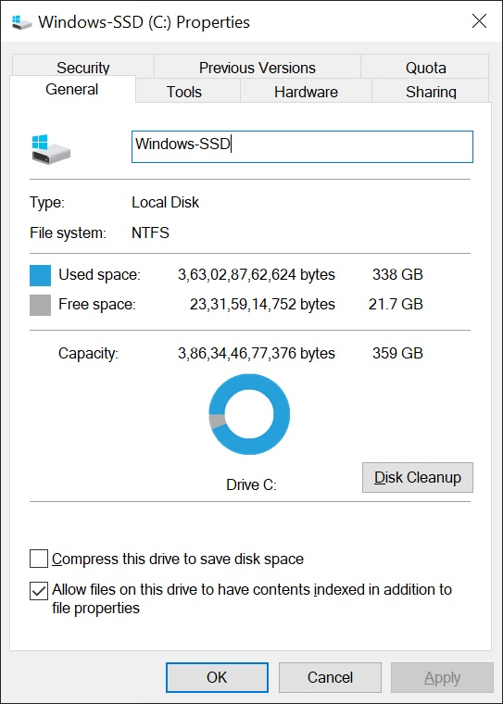

**Figure 4. Windows Drive Properties**

To inspect the file system, navigate to "This PC," and right-click on the desired drive, typically the Windows drive. A context menu will appear, and by selecting "Properties," you can view information about the drive, including the file system. In most cases, you will observe "NTFS" listed next to the file system in the displayed properties.

**FAT32 (File Allocation Table 32)**

While NTFS is the default, Windows 11 still supports FAT32 for compatibility with external storage devices such as USB drives. FAT32 is a simpler file system without the advanced features of NTFS.

FAT32 boasts broad compatibility with both new and older devices. Its longevity has established FAT32 as a de facto standard for numerous machines. This widespread adoption is so extensive that many flash drives are still pre-formatted with FAT32 by default, emphasizing its maximum compatibility across various devices.

**exFAT (Extended File Allocation Table)**

Windows 11 also supports the exFAT file system, particularly for use with large-capacity external storage devices. exFAT is designed to overcome some limitations of FAT32, such as file size restrictions.

The Extended File Allocation Table (exFAT) file system made its debut in 2006, introduced as a middle ground between the older FAT32 and the more advanced NTFS formats. Initially added to Windows XP and Vista operating systems through a software update, exFAT was designed to address certain limitations of FAT32, particularly in terms of file size and storage capacity.

**ReFS (Resilient File System)**

ReFS is another file system available in Windows 11, but it is primarily used for specific scenarios such as data integrity and high-resilience storage requirements. ReFS is not commonly used for general-purpose storage. Per Parmar (2023), Microsoft could be planning to bring ReFS (a new file system) to replace NTFS on specific systems, according to references spotted in the latest Windows 11 preview build.

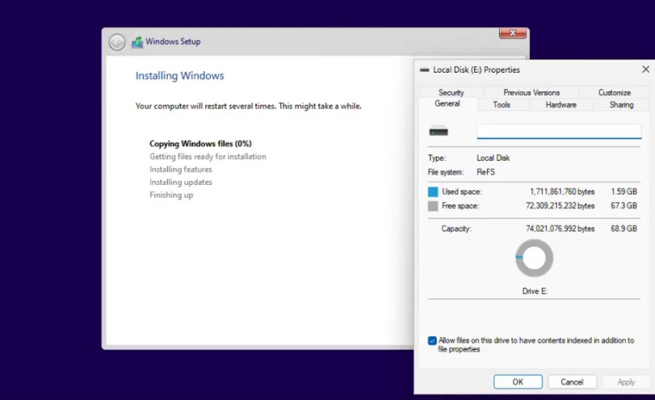

**Figure 5. Windows Drive Properties (2)**

The choice of file system depends on various factors, including the type of storage media, the desired features, and compatibility requirements. NTFS is the preferred choice for internal drives and general-purpose storage, while FAT32 and exFAT are often used for external drives to ensure compatibility with different devices.

**References**

Ahmed, M. (nd). MS Windows 10 CPU Scheduling. Hasan Balik's Lecture Notes. Retrieved from.

<http://www.hasanbalik.com/LectureNotes/OpSys/Assignments/MS%20Windows%2010%20CPU> %20Scheduling.pdf

Akura, R. (2023). History of Windows Operating System. SoftwareKeep Blog. Retrieved from.

<https://softwarekeep.com/blog/history-of-windows-operating-system>

Alliance Tech. (nd). How To Access BIOS In Windows 11. Alliance Tech. Retrieved from.

<https://www.alliancetech.com/how-to-access-bios-in-windows-11/>

Bogna, J. (2023, July). FAT32 vs. ExFAT vs. NTFS: Which Format Is Best for Your Storage Drive? PCmag.

Retrieved from. <https://www.pcmag.com/how-to/fat32-vs-exfat-vs-ntfs-which-format-is-best-for-your-storage-drive>

Buck. (nd). Microsoft Windows 11. Buck. Retrieved from. [https://buck.co/case-study/microsoft-](https://buck.co/case-study/microsoft-%09%20%20%20%20%20windows-11)

windows-11

DevX. (2023, December) I/O Requests. DevX. Retrieved from. <https://www>.devx.com/terms/io-request/

Dhawan, A. (2023, February). Process Management in Operating Systems. DataTrained. Retrieved from.

<https://datatrained.com/post/process-management-os/>

Encyclopaedia Britannica. (2023, December). Microsoft Windows. Encyclopaedia Britannica. Retrieved

from. <https://www.britannica.com/technology/Microsoft-Windows>

GeeksforGeeks. (2023, May). CPU Scheduling in Operating Systems. GeeksforGeeks. Retrieved from.

<https://www.geeksforgeeks.org/cpu-scheduling-in-operating-systems/>

GeeksforGeeks. (2023, December). Introduction of Process Management. GeeksforGeeks. Retrieved from.

<https://www.geeksforgeeks.org/introduction-of-process-management/>

GeeksforGeeks. (2022, February). Windows Memory Management. GeeksforGeeks. Retrieved from.

<https://www.geeksforgeeks.org/windows-memory-managment/>

Goodwill Community Foundation, Inc. (nd). Working with Files. Retrieved from.

https://edu.gcfglobal.org/en/windowsbasics/working-with-files/1/

Huculak, M. (2022, April). How to manage storage devices on Windows 11. Retrieved from.

<https://www.windowscentral.com/how-manage-storage-devices-windows-11>

Huculak, M. (2023, April). Windows 11 NTFS vs. ReFS: How do these file systems differ? Pureinfotech.

Retrieved from. <https://pureinfotech.com/windows-11-ntfs-vs-refs-file-systems-differ/>

LearningOperatingSystem. (2015, September). Explain MS Windows process management. Learning Operating System. Retrieved from.

<https://learningoperatingsystem.blogspot.com/2015/09/6.html>

Lutkevich, B. (2020, November). BIOS (basic input/output system). TechTarget. Retrieved from.

<https://www.techtarget.com/whatis/definition/BIOS-basic-input-output-system>

Microsoft. (2021, January). About Memory Management. Microsoft Learn. Retrieved from.

<https://learn.microsoft.com/en-us/windows/win32/memory/about-memory-management>

Microsoft. (2021, January). Processes and Threads. Microsoft Docs. Retrieved from.

<https://learn.microsoft.com/en-us/windows/win32/procthread/processes-and-threads>

Microsoft Community. (2023, March). App Optional Features - Windows Storage Management. Retrieved

from. <https://answers.microsoft.com/en-us/windows/forum/all/app-optional-features-windows-storage-management/2ccba1e5-b78f-4bee-8acf-ab99d80bd880>

Panay, P. (2021, June). Introducing Windows 11. Windows Blog. Retrieved from.

<https://blogs.windows.com/windowsexperience/2021/06/24/introducing-windows-11>

Parmar, M. (2023, January). Windows 11 is getting a new file system (ReFS), but Microsoft won’t ditch

NTFS. Windows Latest. Retrieved from. <https://www.windowslatest.com/2023/01/24/windows-11-is-getting-a-new-file-system-refs-but-microsoft-wont-ditch-ntfs/>

Rizal, S. (nd). Case Study on Windows. Website or Source. Retrieved from.

<https://sritsense.weebly.com/uploads/5/7/2/7/57272303/windows_os.pdf>

Quora. (nd). What file system does Windows 11 use? Quora. Retrieved from.

<https://www.quora.com/What-file-system-does-Windows-11-use#:~:text=The%20Windows%2011%2C%2010%2C%208.1,read%2Donly%20support%20for%20NTFS>.

Quora. (nd). Which scheduling algorithm is used in Windows 11? Quora. Retrieved from.

<https://www.quora.com/Which-scheduling-algorithm-is-used-in-Windows-11>

Sattar, A. (2023). CPU scheduling in Windows Operating System. Studocu. Retrieved from.

<https://www.studocu.com/row/document/university-of-gujrat/database-system/cpu-scheduling-in-windows-operating-system/21133062>

Sheldon, R. (2020, June). Memory Management. TechTarget. Retrieved from.

<https://www.techtarget.com/whatis/definition/memory-management#:~:text=Memory%20management%20is%20the%20process,to%20carry%20out%20their%20operations>.

Silberschatz, Galvin & Gagne. (2013). Operating System Concepts 9th edition.

Stack Overflow. (2022, November). What is Windows Process Model States? - Process Model. Stack

Overflow. Retrieved from. <https://stackoverflow.com/questions/69726972/what-is-windows-process-model-states-process-model>

Terra, J. (2023, February). What is BIOS? A Guide for Beginners. Simplilearn. Retrieved from.

<https://www.simplilearn.com/what-is-bios-article#:~:text=BIOS%20Availability,of%20any%20machine's%20operating%20system>.